**Assignment 4.1**

**(C++)**

1. **WAP to print “Hello World” using C++.**

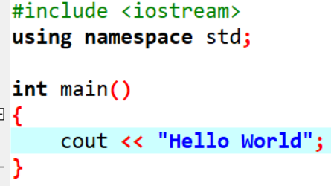



1. **What is OOP? List OOP concepts.**

* **Object-oriented programming (OOP) is a computer programming model that organizes software design around data, or objects, rather than functions and logic. An object can be defined as a data field that has unique attributes and behavior.**
* **List OOP Concepts:**

**Class**

**Object**

**Inheritance**

**Data Abstraction**

**Data Encapsulation**

**Polymorphism**

**Overloading**

**Reusability**

* **Class :**

**Class is a blueprint for creating objects.** **These contain data and functions bundled together under a unit. In other words class is a collection of similar objects. When we define a class it just creates template or Skelton. It defines the attributes(data members) and methods (functions) that the objects of that class will have.**

* **Object:**

**Object is a instance of class. It represent real world entity with specific characteristic and behaviours.** **There can be more than one instance of a class. Each instance of a class can hold its own relevant data.**

* **Inheritance :**

**Inheritance is the process of forming a new class from an existing class or base class. The base class is also known as parent class or super class. The new class that is formed is called derived class. Derived class is also known as a child class or sub class. Inheritance helps in reducing the overall code size of the program.**

* **Data Abstraction :**

**Data Abstraction increases the power of programming language by creating user defined data types. Data Abstraction also represents the needed information in the program without presenting the details.**

* **Data Encapsulation :**

**Data Encapsulation combines data and functions into a single unit called class. When using Data Encapsulation, data is not accessed directly; it is only accessible through the functions present inside the class. Data Encapsulation enables the important concept of data hiding possible.**

* **Polymorphism :**

**Polymorphism allows routines to use variables of different types at different times. An operator or function can be given different meanings or functions. Polymorphism refers to a single function or multi-functioning operator performing in different ways. In C++ polymorphism is offer acheived through function overloading and virtual function.**

* **Overloading :**

**Overloading is one type of Polymorphism. It allows an object to have different meanings, depending on its context. When an existing operator or function begins to operate on new data type, or class, it is understood to be overloaded.**

* **Reusability :**

**This term refers to the ability for multiple programmers to use the same written and debugged existing class of data. This is a time saving device and adds code efficiency to the language.**

1. **What is the difference between OOP and POP?**

|  |  |  |
| --- | --- | --- |
| **Type** | **POP** | **OOP** |
| **Full Name** | **Procedure Oriented Programming** | **Object-Oriented Programming** |
| **Divided Into** | **In POP, the program is divided into small parts called functions.** | **In OOP, the program is divided into parts called objects.** |
| **Importance** | **In POP, functions and the order of operations to be performed take precedence over data.** | **Because it works in the actual world, data takes priority over procedures and functions in OOP.** |
| **Approach** | **POP follows the Top-Down approach.** | **OOP follows the Bottom-Up approach.** |
| **Access Specifies** | **POP does not have any access specified.** | **OOP has access specifies named Public, Private, Protected, etc.** |
| **Data Moving** | **In POP, Data can move freely from function to function in the system.** | **In OOP, objects can move and communicate with each other through member functions.** |
| **Expansion** | **To add new data and functions in POP is not so easy.** | **OOP provides an easy way to add new data and functions.** |
| **Data Access** | **Most functions in POP employ global data for sharing, which can be accessed freely from one function to the next.** | **Data in OOP cannot simply flow from one function to function; it can be kept public or private, allowing us to regulate data access.** |
| **Data Hiding** | **POP does not have any proper way for hiding data so it is less secure.** | **OOP provides Data Hiding so provides more security.** |
| **Overloading** | **In POP, Overloading is not possible.** | **In OOP, Overloading is possible in the form of Operator Overloading and Function Overloading.** |
| **Examples** | **Examples of POP are C, VB, FORTRAN, Pascal.** | **Examples of OOP are C++, JAVA, VB.NET, C#.NET.** |

**Assignment 4.2**

1. **WAP to create simple calculator using class.**

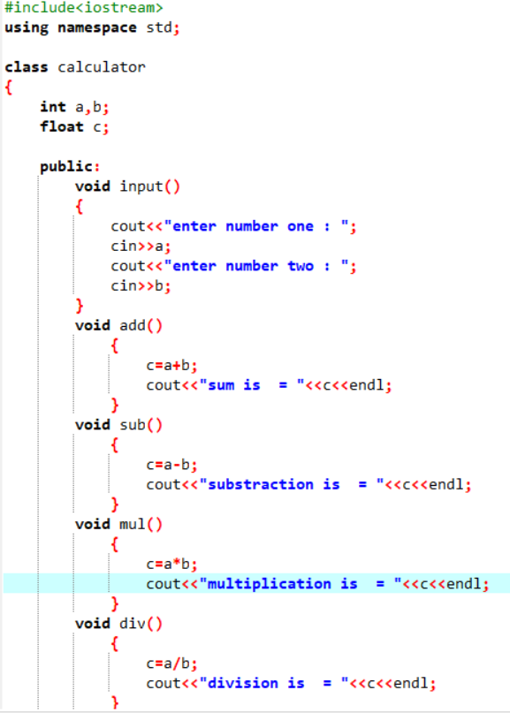

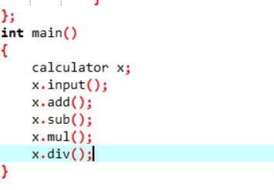

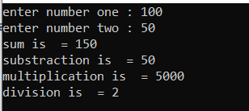

**2)** **Define a class to represent a bank account. Include the following members:**

**1. Data Member: -Name of the depositor -Account Number -Type of Account -Balance amount in the account**

**2. Member Functions -To assign values -To deposited an amount -To withdraw an amount after checking balance -To display name and balance**

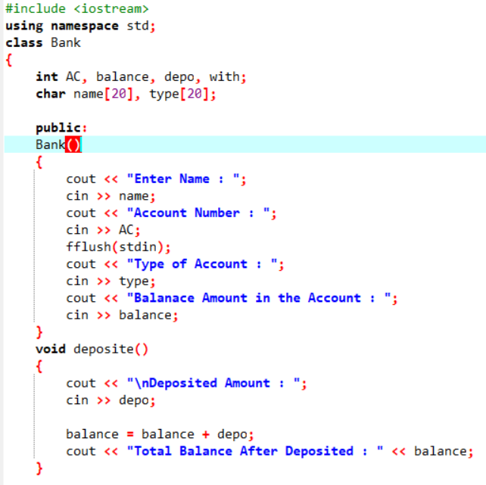

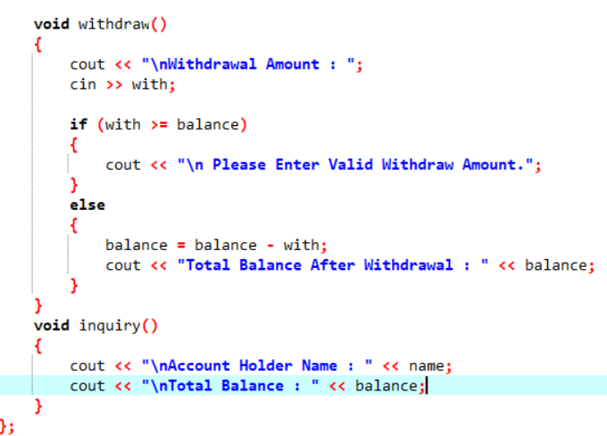

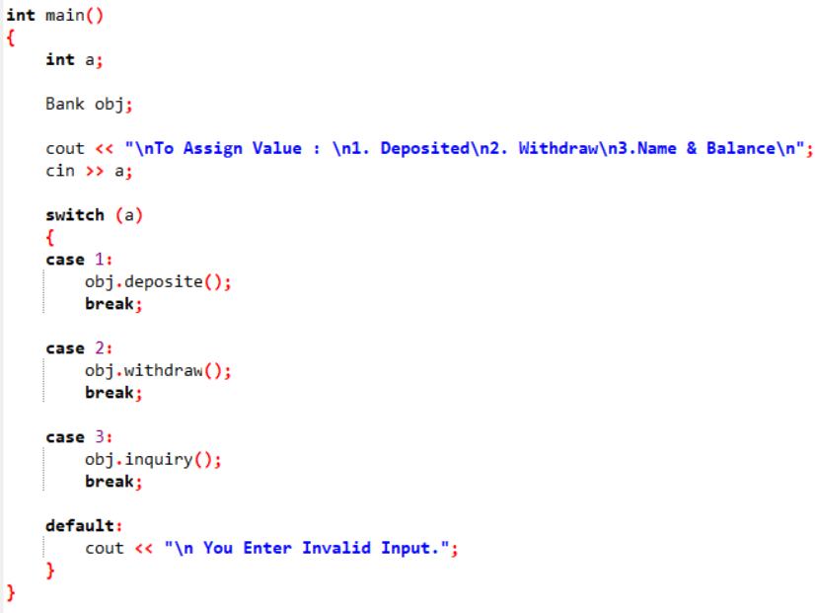

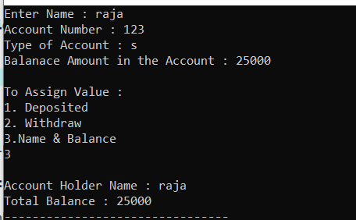

**3 Write a program to find the multiplication values and the cubic values using inline function.**

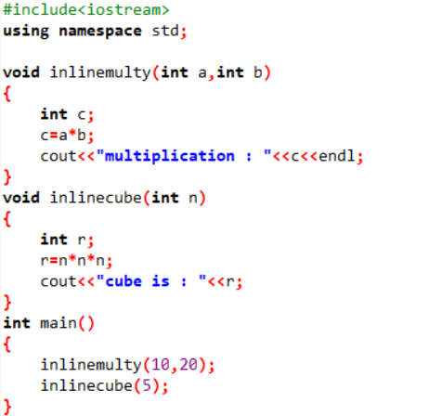



**4 Write a program of Addition, Subtraction, Division, Multiplication using constructor.**

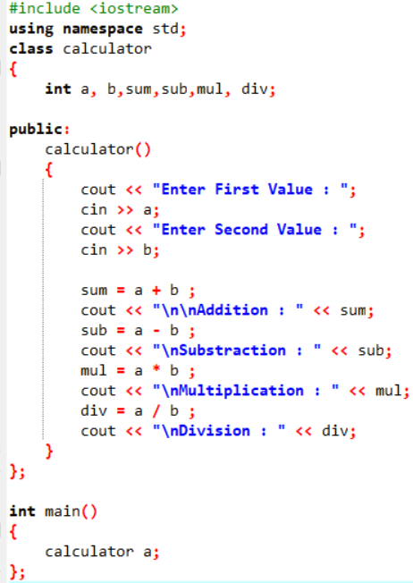

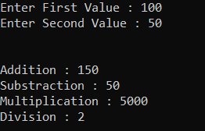

**5 Assume a class cricketer is declared. Declare a derived class batsman from cricketer. Data member of batsman. Total runs, Average runs and best performance. Member functions input data, calculate average runs, Display data. (Single Inheritance)**

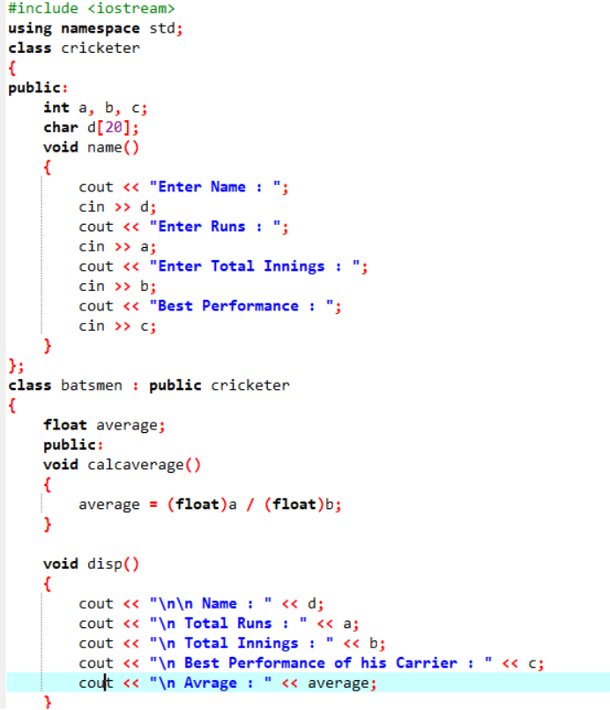

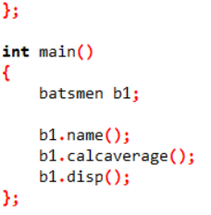 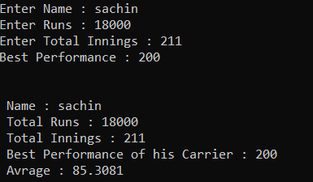

**6 Create a class person having members name and age. Derive a class student having member percentage. Derive another class teacher having member salary. Write necessary member function to initialize, read and write data. Write also Main function (Multiple Inheritance)**

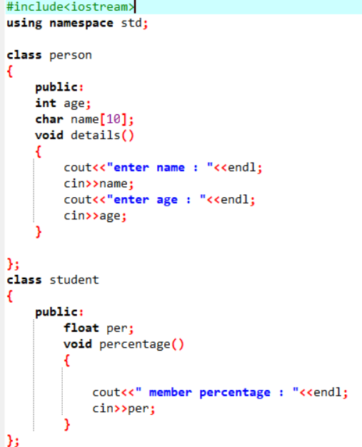

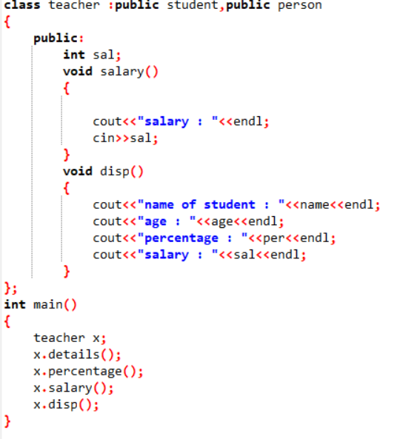

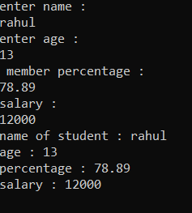

**7 Assume that the test results of a batch of students are stored in three different classes. Class Students are storing the roll number. Class Test stores the marks obtained in two subjects and class result contains the total marks obtained in the test. The class result can inherit the details of the marks obtained in the test and roll number of students. (Multilevel Inheritance)**

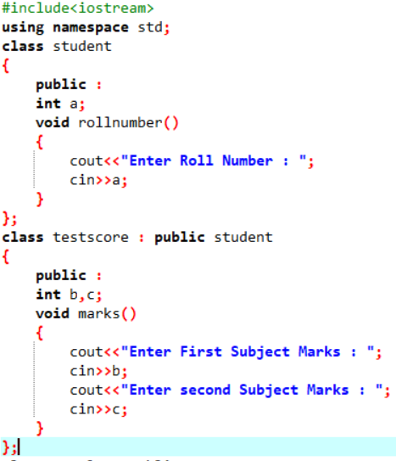

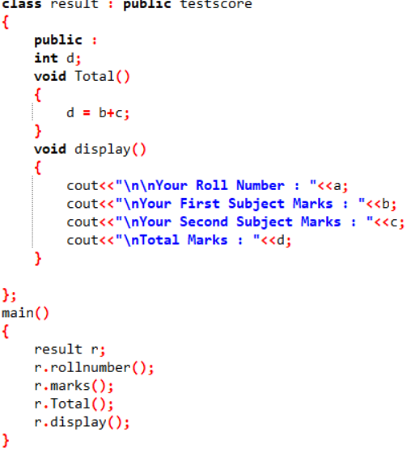

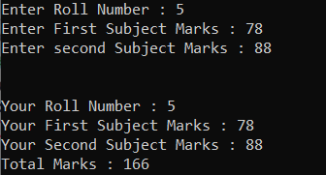

**8 Write a program to Mathematic operation like Addition, Subtraction, Multiplication, Division Of two number using different parameters and Function Overloading**

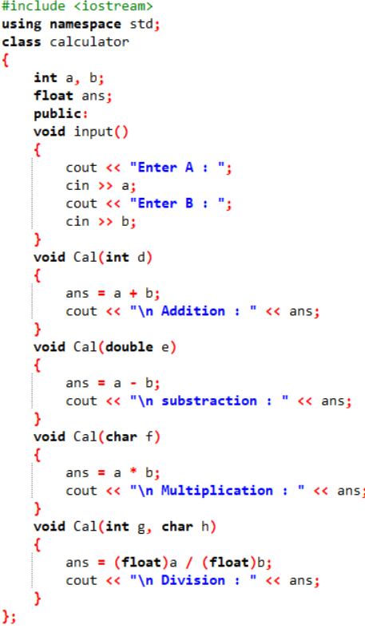

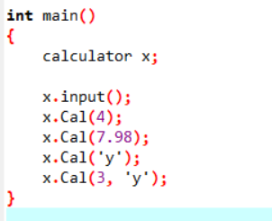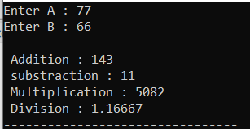

**9 Write a program to concatenate the two strings using Operator Overloading**

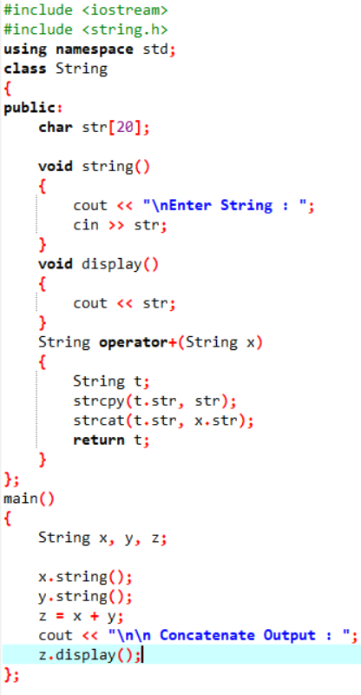

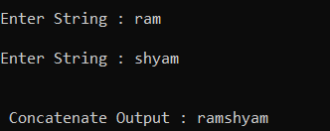

**10 Write a program to calculate the area of circle, rectangle and triangle using Function Overloading Rectangle: Area * breadth Triangle: ½ *Area* breadth Circle: Pi * Area *Area**

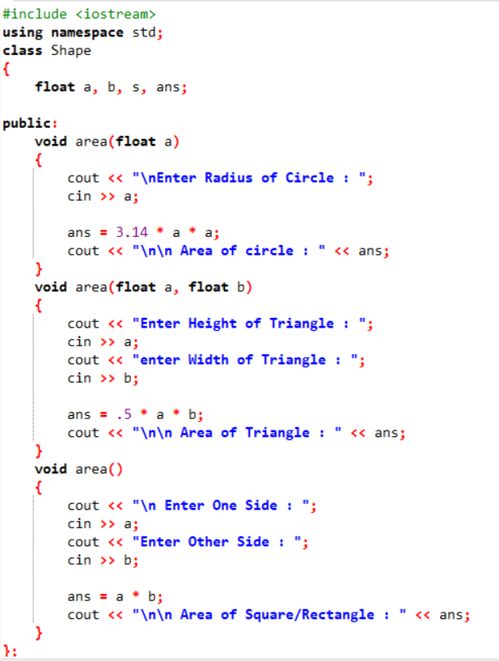

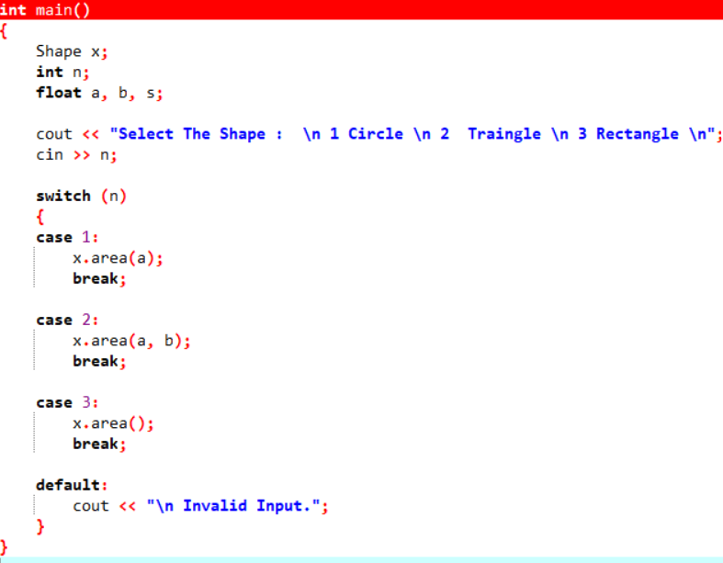

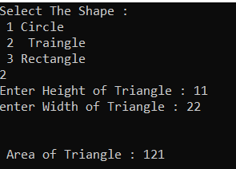

**10 Write a program to swap the two numbers using friend function without using third variable**

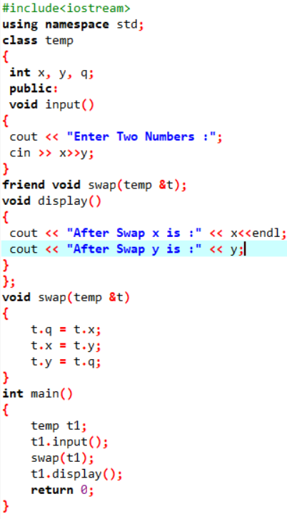

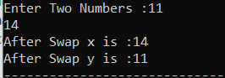

**11 Write a program to find the max number from given two numbers using friend function.**

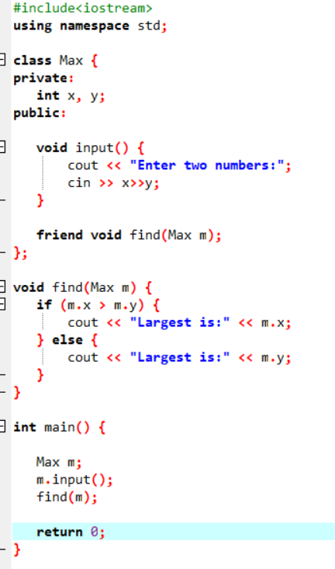

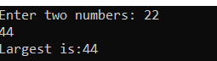

**ASSIGNMENT 4.2**

**1 Write a program of to swap the two values using templates**

